Group 5

Brandon Hackett

Darnell Lewis

Derek Livermont

Lindsey Yin

Bacchus Winery Case Study

CSD 310 Module 11

Milestone #3

Distributor Wine Report Description:

This Python script generates a report that provides information on which distributor carries which wine. It achieves this by retrieving data from the `wine_order_line`, `wine_order`, `distributor`, and `wine` tables through SQL joins. The report displays the distributor name along with the corresponding wine types they carry. This information is crucial for business decisions, as it allows the winery owners to understand the distribution network and popularity of different wines among distributors.

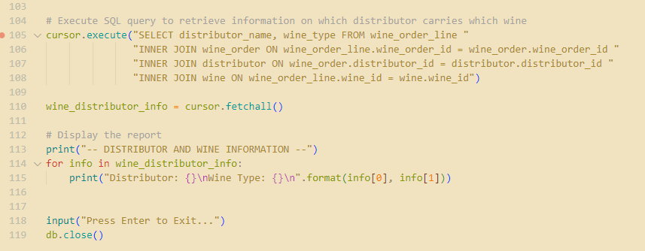

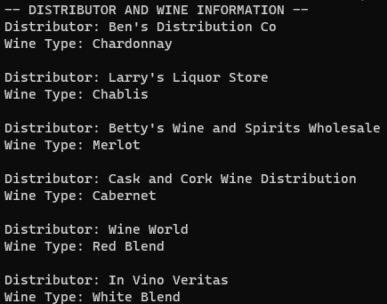

Total Sales by Wine Type Report:

This Python script generates a report that provides information on total wine sales by type. It achieves this by retrieving data from the `wine_order_line` and `wine` tables through SQL joins. The report displays the Each type of wine, quantity sold and the calculated sales for that wine. The report is sorted by lowest sales to highest. This report can be used by the owners to understand which wines are preforming the lowest and which wines are selling well.

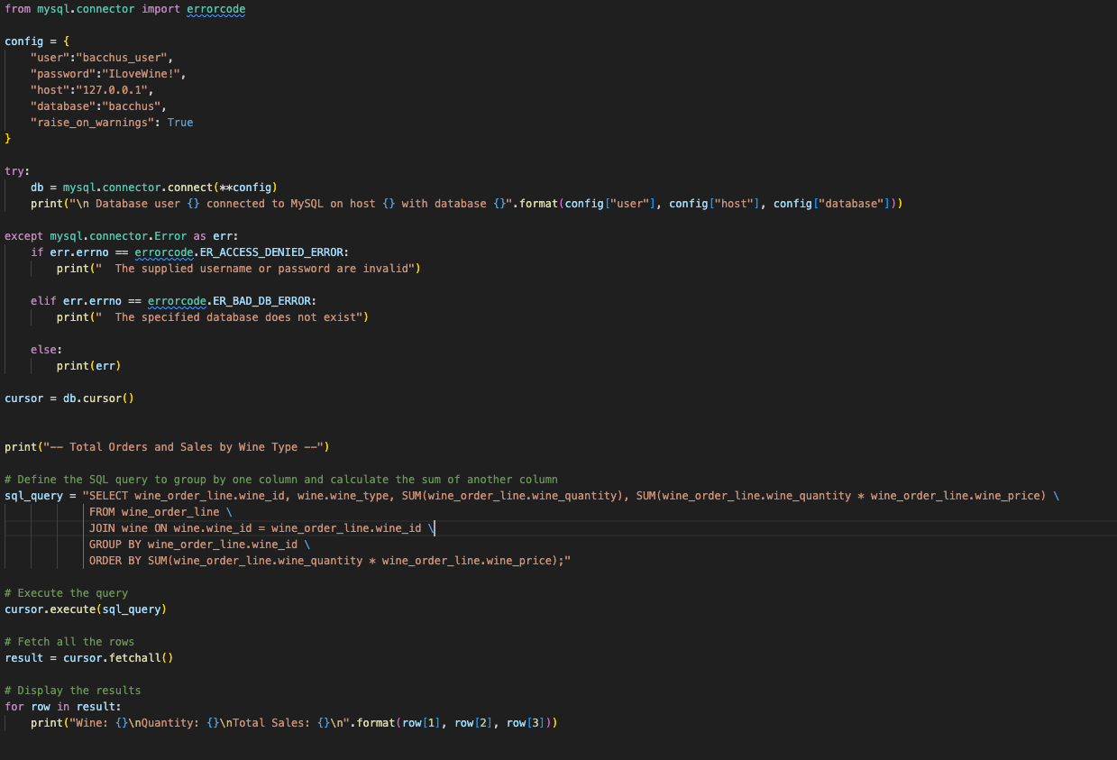

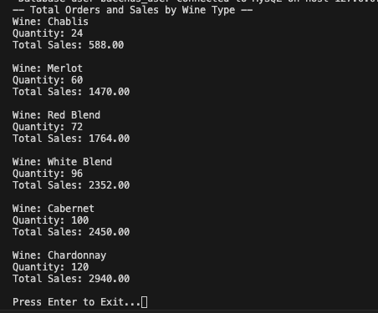

Employee Shift Report

This report will draw up all shift records for a range of time periods. Although this is just one iteration of the script, it shows the flexibility of our database design. For example, as it’s written, this script pulls up all the shift records for the one day of sample data we have. However, the BETWEEN statement could be attached to a front-end where a custom time-period could be pulled up. Additionally, a HAVING statement could be added to isolate a single employee for a payroll report.

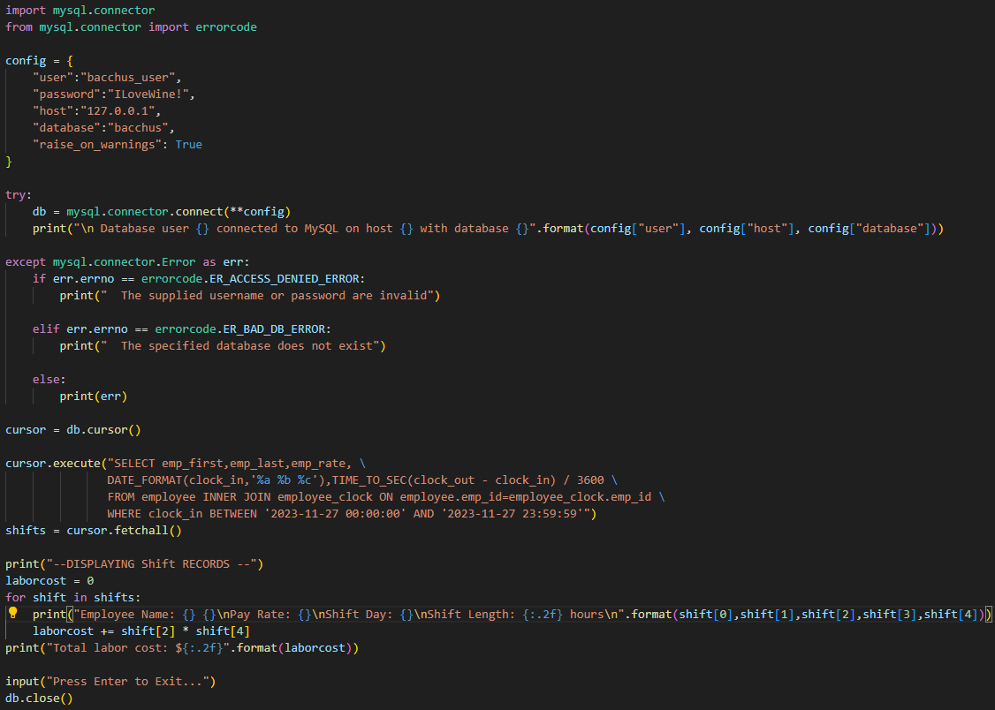

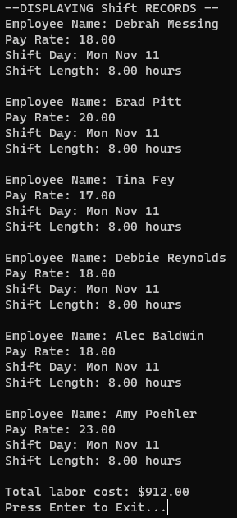

Late Order Report

This report pulls up every delivery where the actual delivery happened after the expected delivery. This pulls up every delivery within the sample data but could be easily adjusted into a front end where managers can enter specific periods that would be fed into a WHERE statement to narrow down results.

